# **EventRequest Database**

Note: I have used MySQL server and MySQL workbench (client application)

1. **Create Statement**

CREATE TABLE EventRequest(

Eventno varchar(8) NOT NULL,

Dateheld DATE NOT NULL,

DateReq DATE NOT NULL,

Custno varchar(8) NOT NULL,

Facno varchar(8) NOT NULL,

Dateauth DATE,

Status varchar(20) NOT NULL,

Estcost decimal(10,2) NOT NULL,

Estaudiences integer NOT NULL,

Budno varchar(50),

CONSTRAINT Eventnopk PRIMARY KEY(Eventno),

CONSTRAINT FacnoFK FOREIGN KEY(Facno) REFERENCES Facility(Facno),

CONSTRAINT CustnoFK FOREIGN KEY(Custno) REFERENCES Customer(Custno),

CHECK (Status IN ('Pending','Denied','Approved')),

CHECK (Estaudience > 0)

);

Output:



1. **Desc Table**

DESC EventRequest;

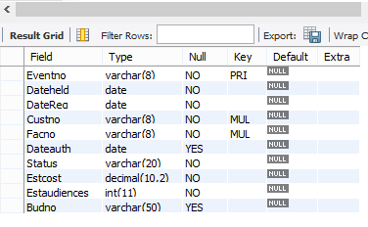

1. **EventRequest Table rows**

SELECT * FROM EventRequest;

